How to Give the Exam
Step 1 : Click Exam Login and enter your UserName and Password which is sent to your mobile and on Email id.
(Instruction: if you forget the User Login and password then click on Forgot Credentials and enter the required parameter.)

Step 2:
After Login following Examination Details page will display .
Please click on Apply to exam name.

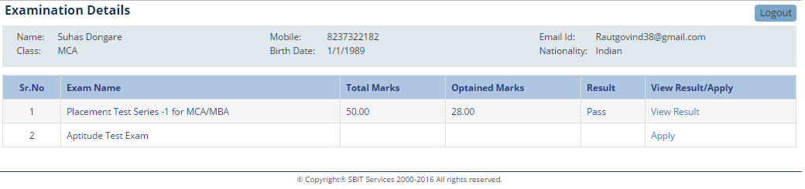

Step 3: Read all instruction before start examination and click on acceptance .
To start the Exam please click on start Exam button.
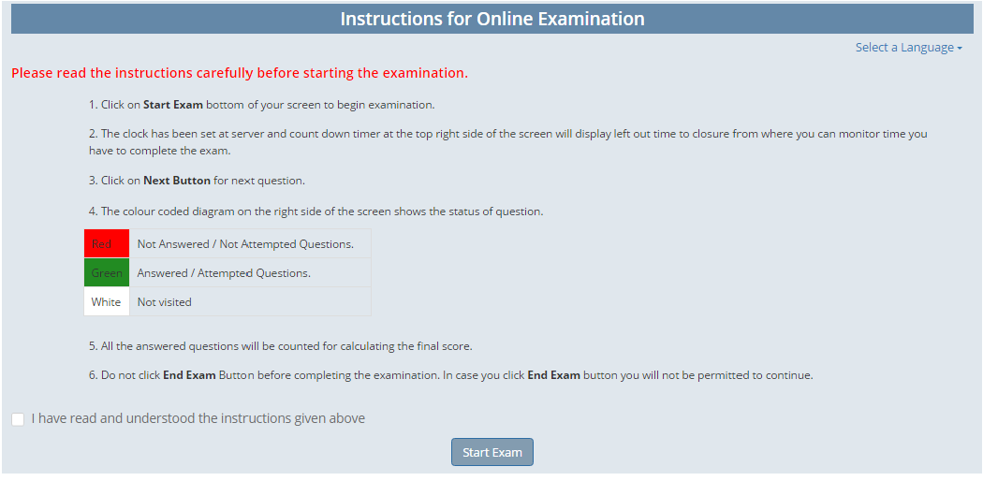

Step 4:
Save and Next: click save and Next button to display next question
Save and previous button: click save and previous button to display previous question
End Exam : click End Exam button to End Exam.
If Exam time is over logout automatically.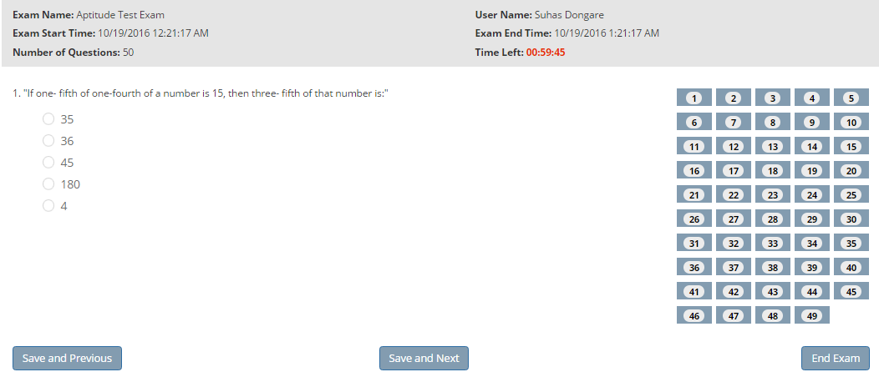

Step 5: After end of Exam result will display on same screen, and also to your mobile as well as Email.

Note: For any query please contact Mobile No: 9604050623 ,9595968619

