- Result Information

- After Exam you can see the result.

- Step1: 1 You need to login again and you will see the examination details, how many exam you have given.

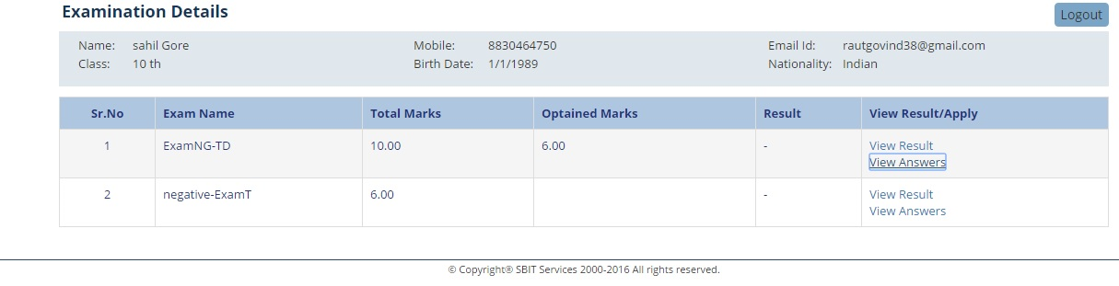

- In front of exam link of “View Result” and “View Answer”.

- Step: 2 In “View Result” you can see Name, Exam name which exam you have given, total number of question ,answered question, total marks , obtained marks and result status ‘Pass’ or ‘Fail’.

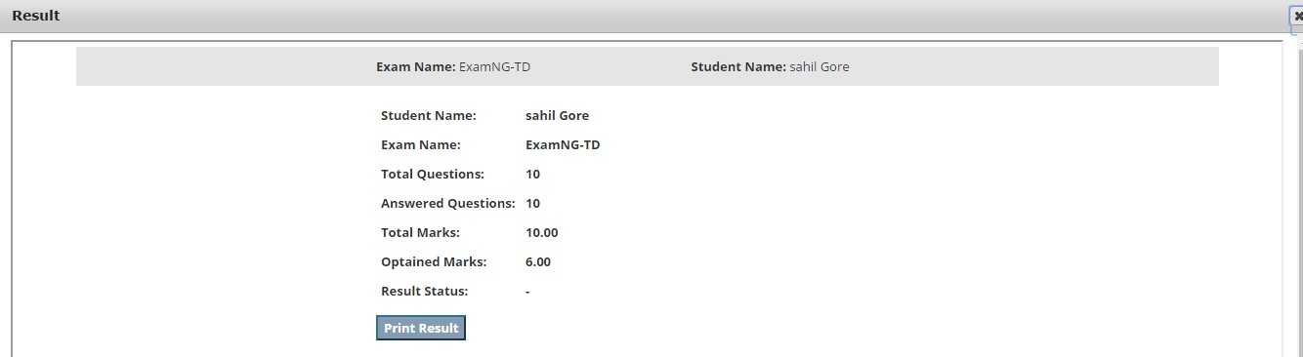
- Step :3 In “View Answer” you can see the each question, answer of that question you have given,
Valid answer and explanation of that answer.

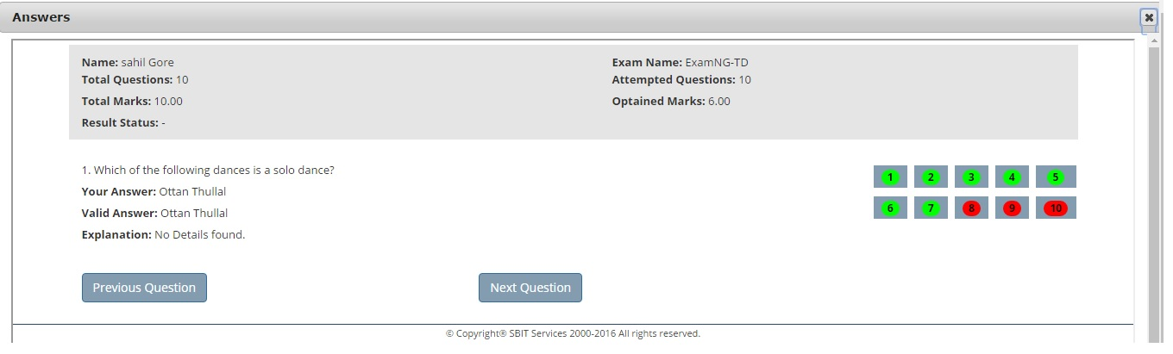
- You can see each and every questions answer and explanation.

