How to Register for the Online Examination

- Step 1: To create an account and start creating tests just go to our website http://www.eazy2exam.online and click "Register" in the upper-right corner of the screen.

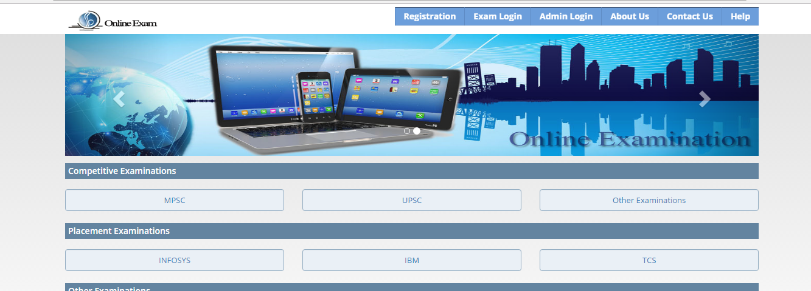

- Step 2: There are multiple exam links given, on click of any exam link you will redirect to the registration page of that exam.

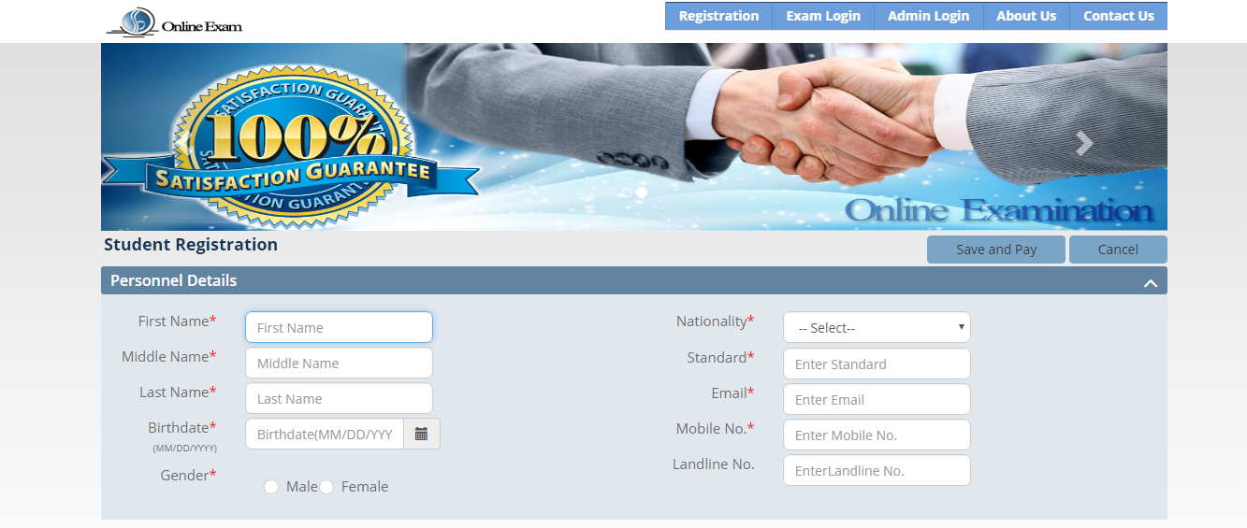

- Step 3: You have to fill the Personnel details and click on “Save and Pay” button.

- Step 4: You will get credential i.e. username and password for exam via Mail and SMS.

- Step 5: You have to fill the payment amount for the exam and click on “proceed to payment” button for further process.

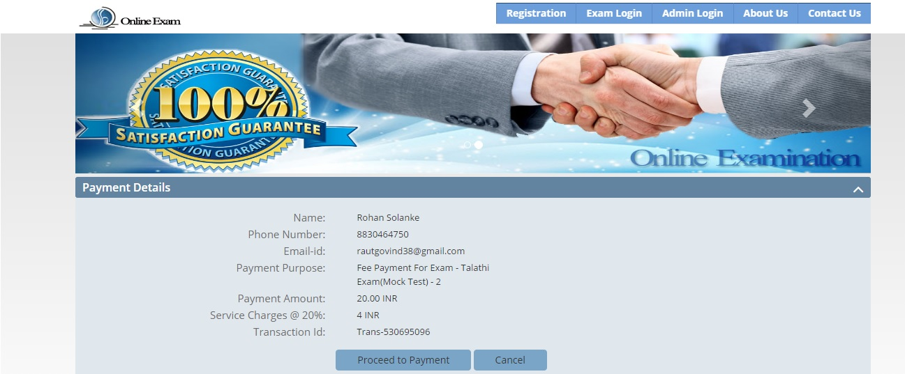

- Step 6: Then you have to select Payment mode for exam using online payment gateway to pay amount.

- Step 7: If you click on “cancel” button you will be redirect to Index Page and your payment will fail.

- Step 8: After payment you will redirect to login page.

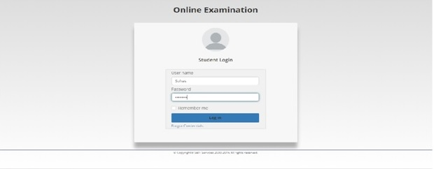

- Step 9: As you have got the credential via SMS and mail using that you can login and appear for exam.

